**C++**

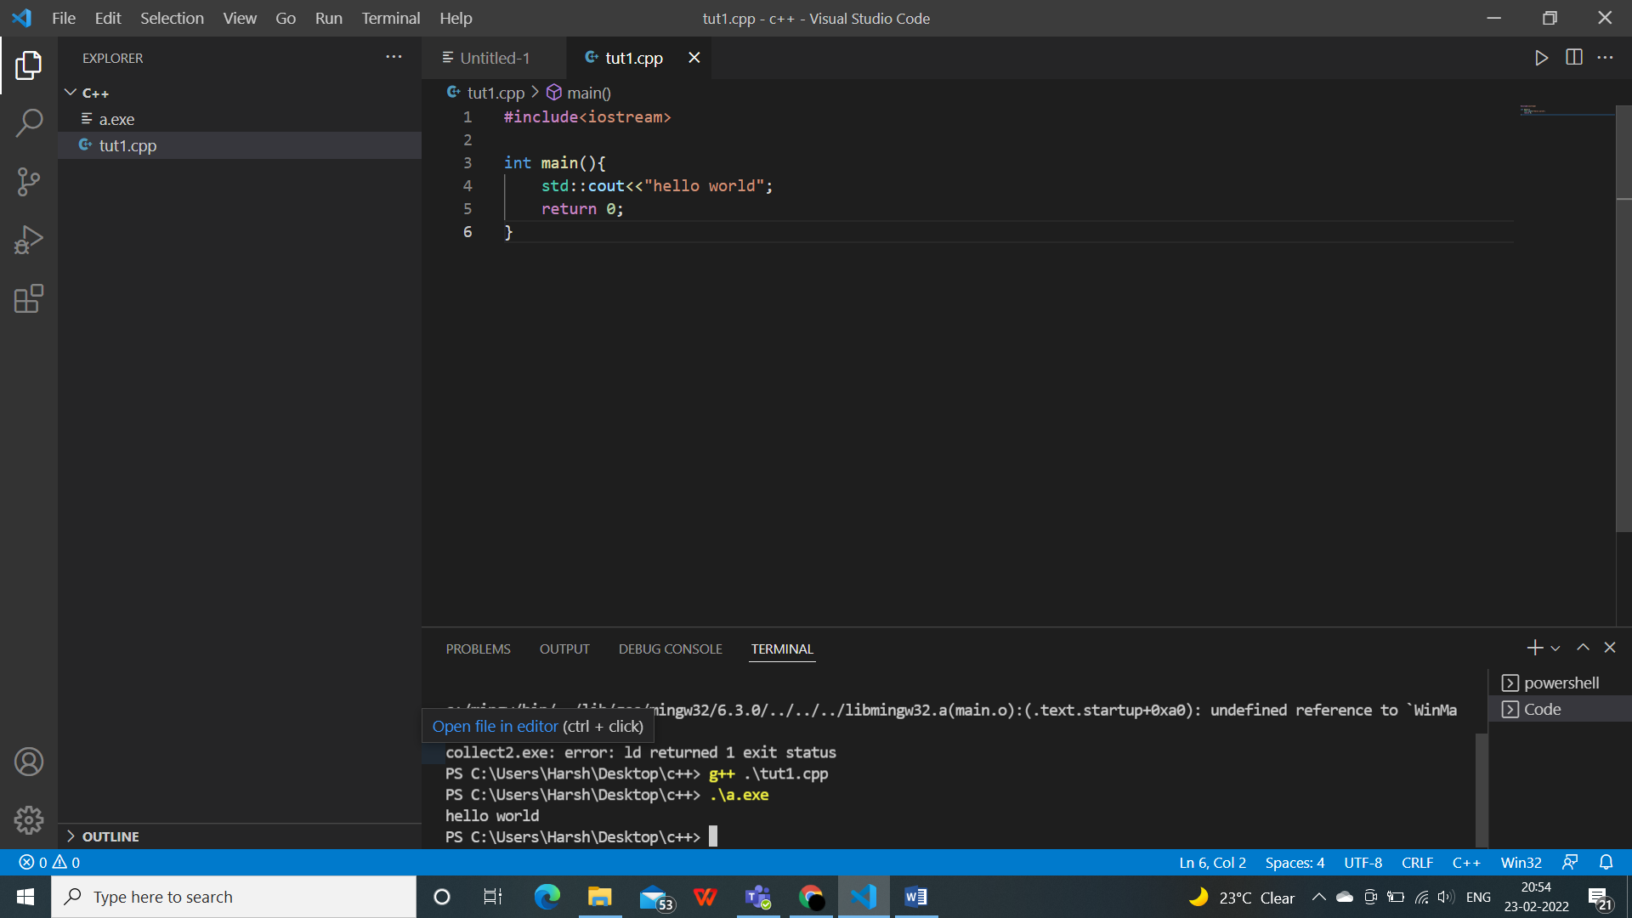

1. We have written our first code and installed few extensions(c++ and code runner)



#include<iostream>

int main(){

    std::cout<<"hello world";

    return 0;

}

iostream--->header file(existing file,enhances functionality,used to generate input and output)

int---> integer

main--->function(first function, entry point, brackets mean it’s a function())

cout,cin---> standard functions

High level language: similar to normal language, logically sound.

Low level language: for hardware level,0&1.

Variables and comments

Variables: containers to store your data

Comments: not a part of the code, used to bring more clarity in the code for understanding, //, /*…*/, ctrl+/-->short cut for commenting out everthing.

(press f2 to rename a file)

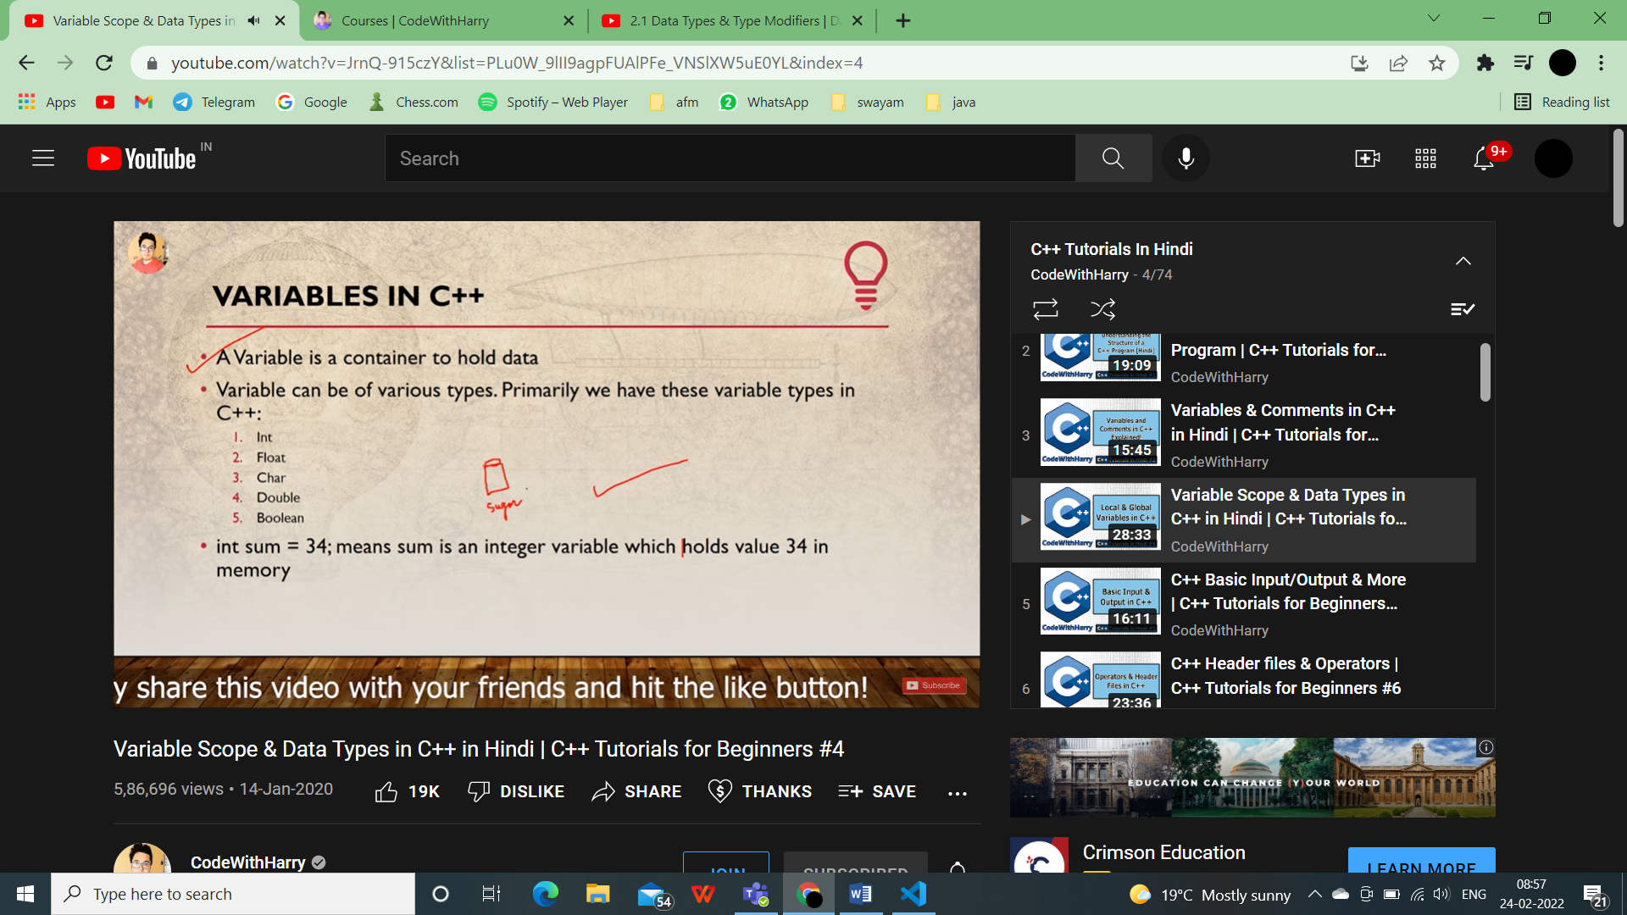

Int: integers

Float: decimals upto 2 places

Char: character, ‘a’,’f’..

Double: decimals upto many places

Boolean: true or false

Data_type variable_name = value;

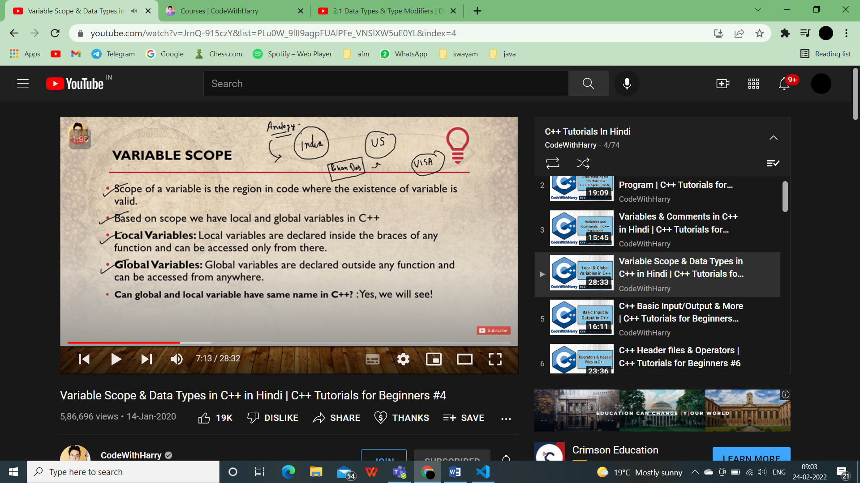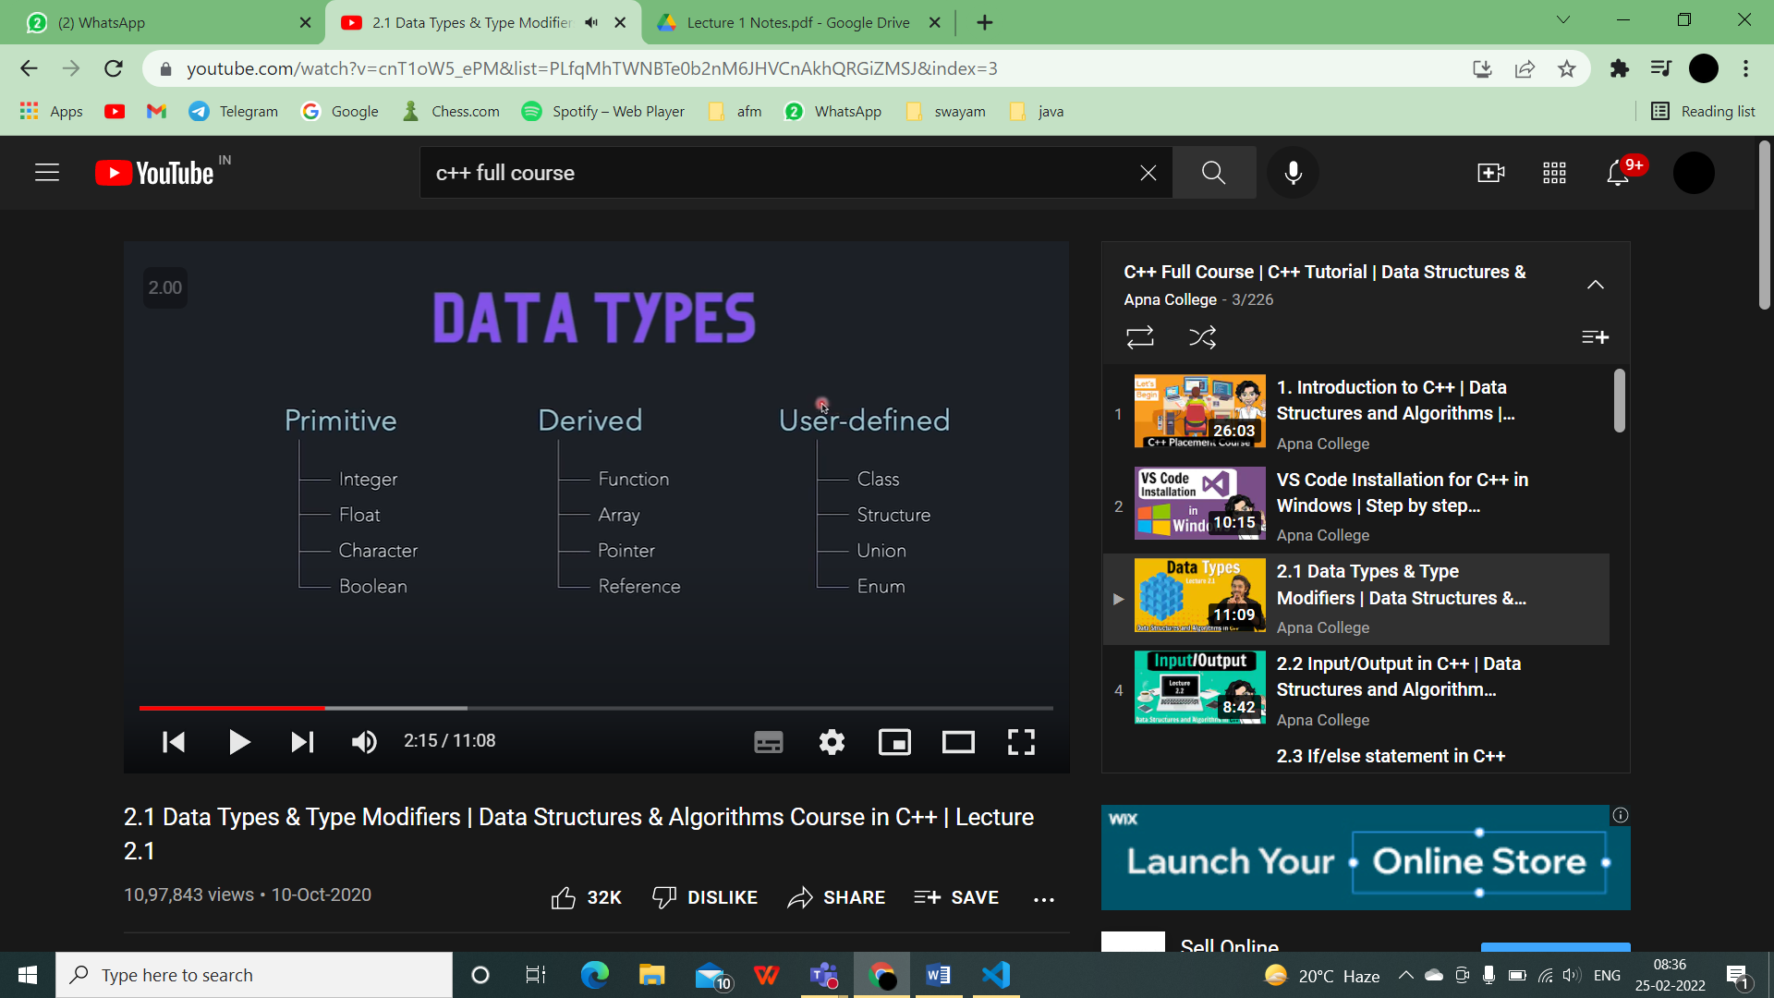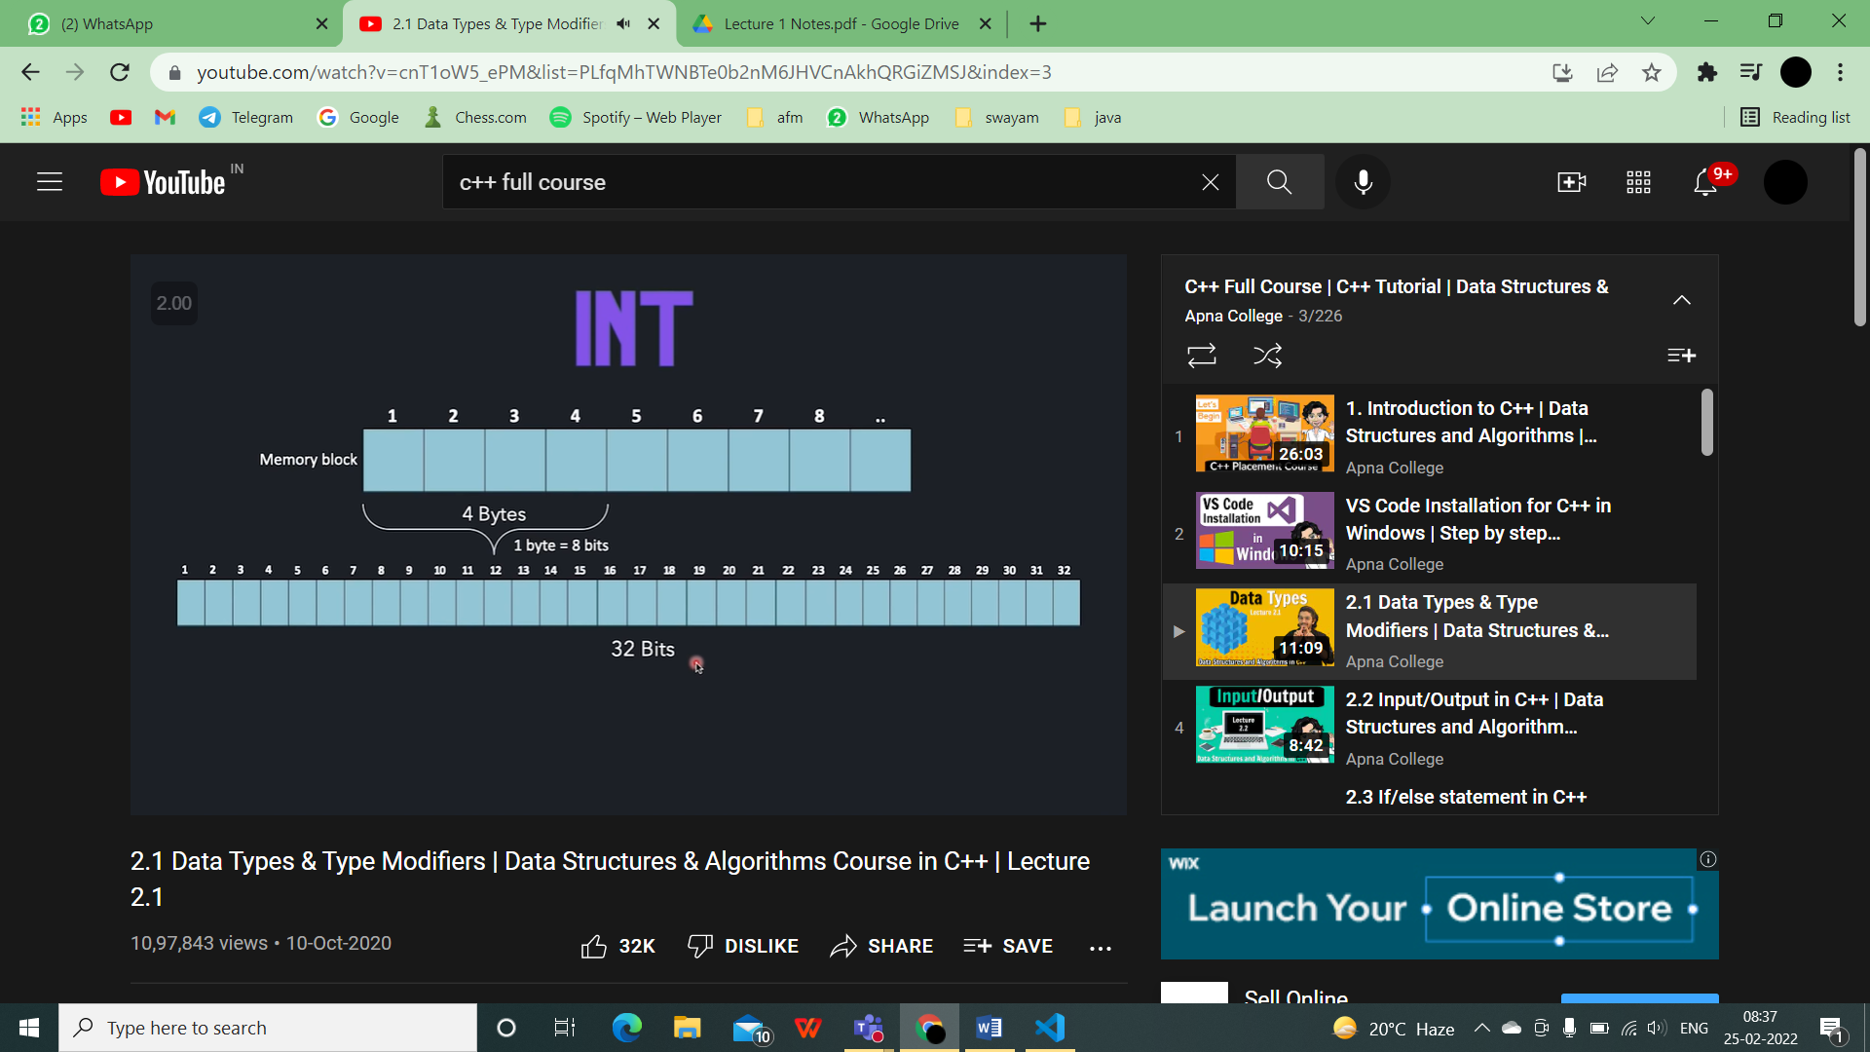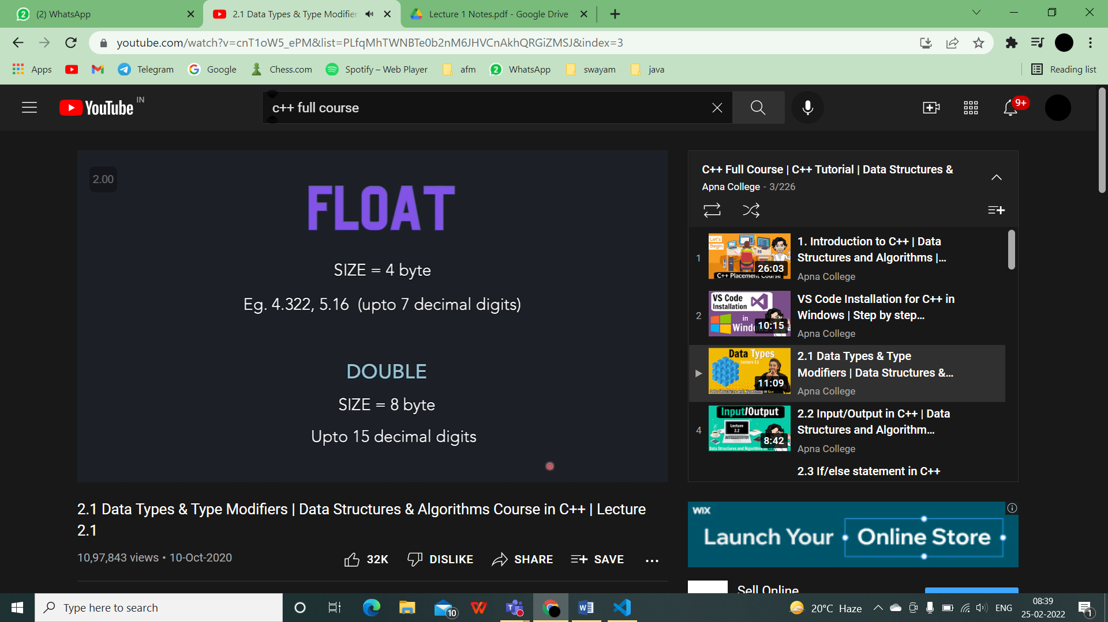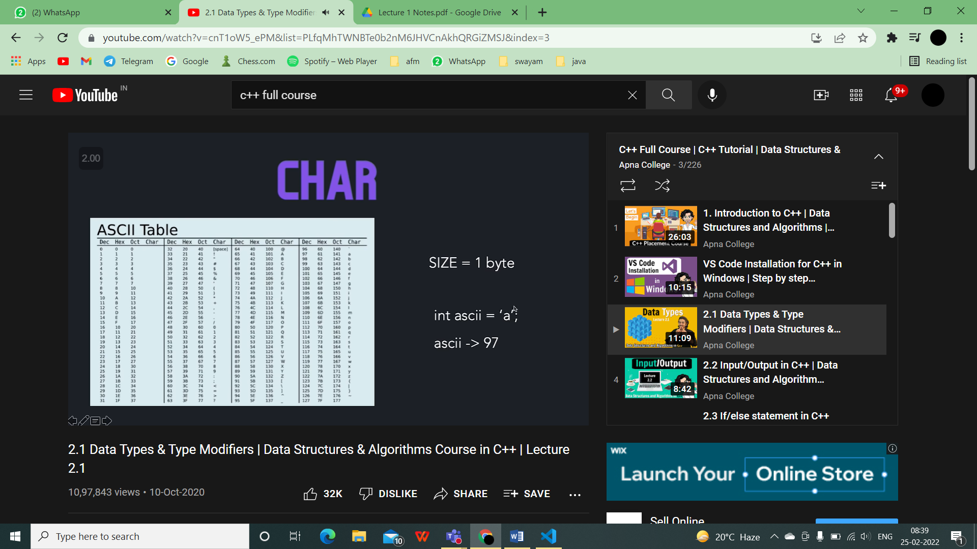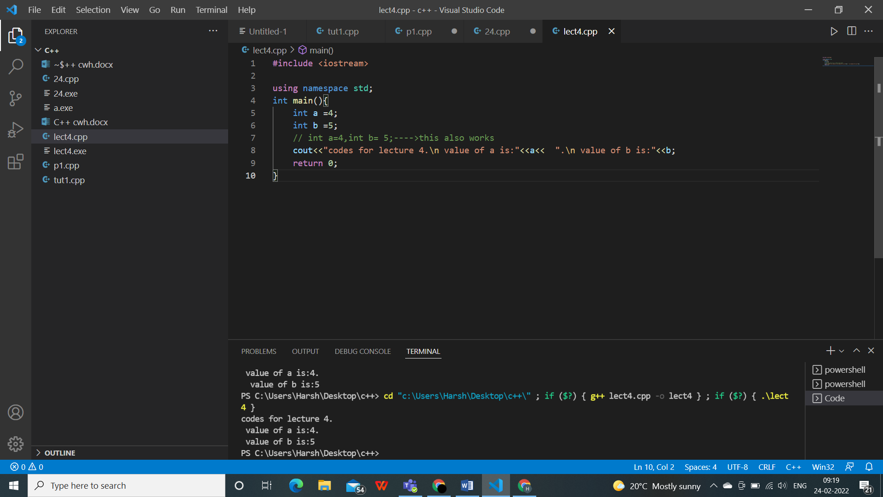

\n---->for getting output in the next line.

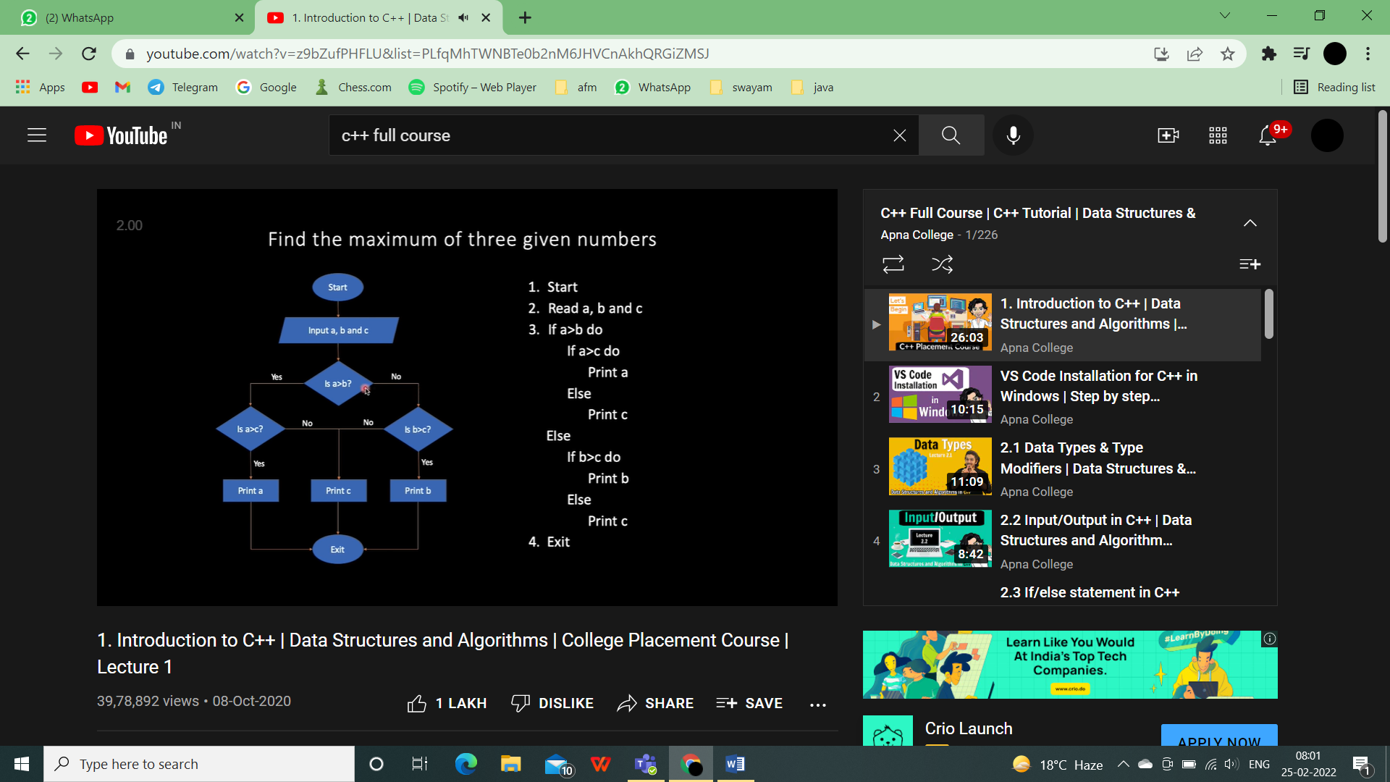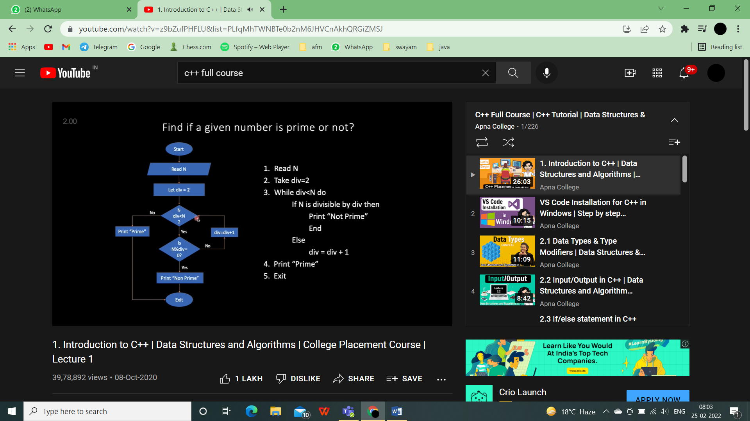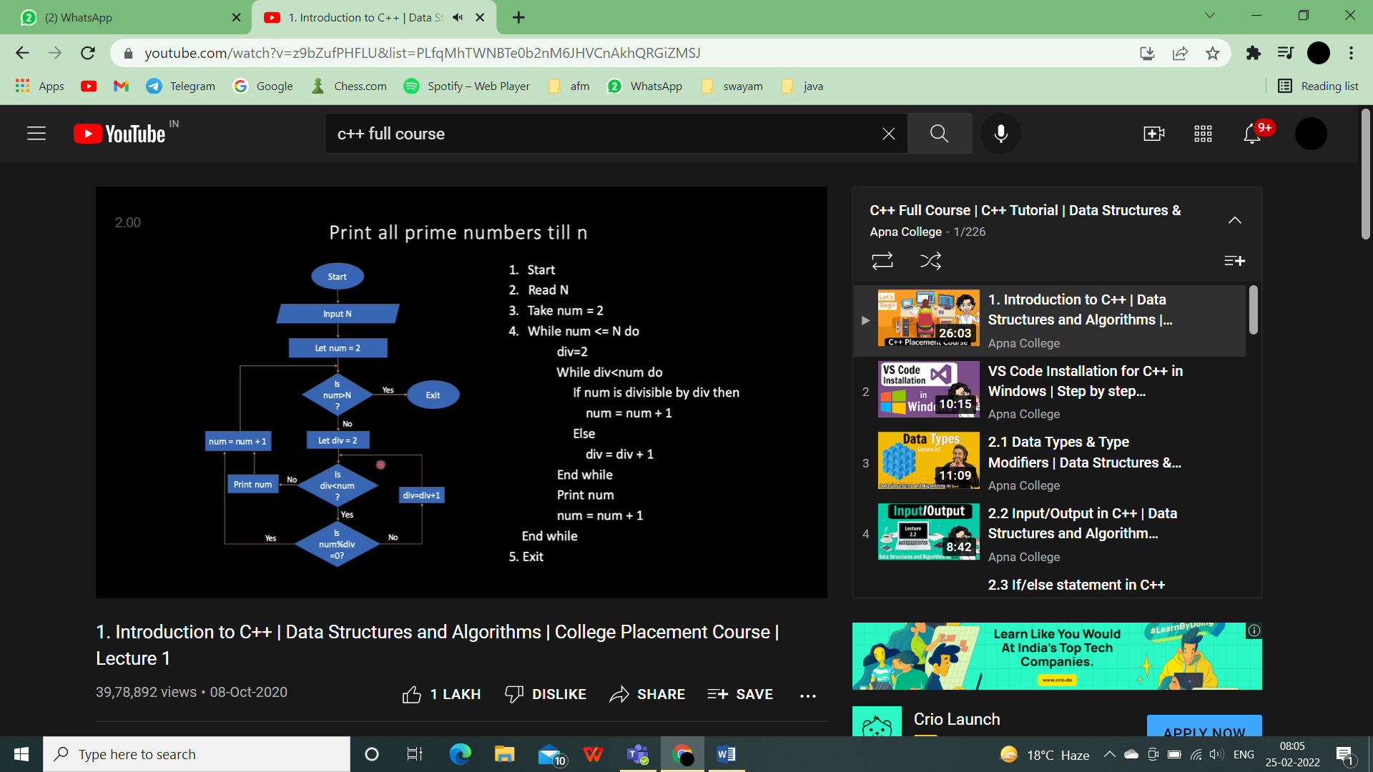

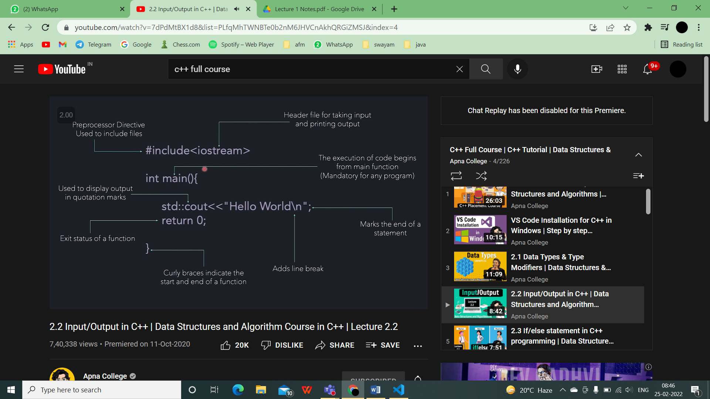

Input from user

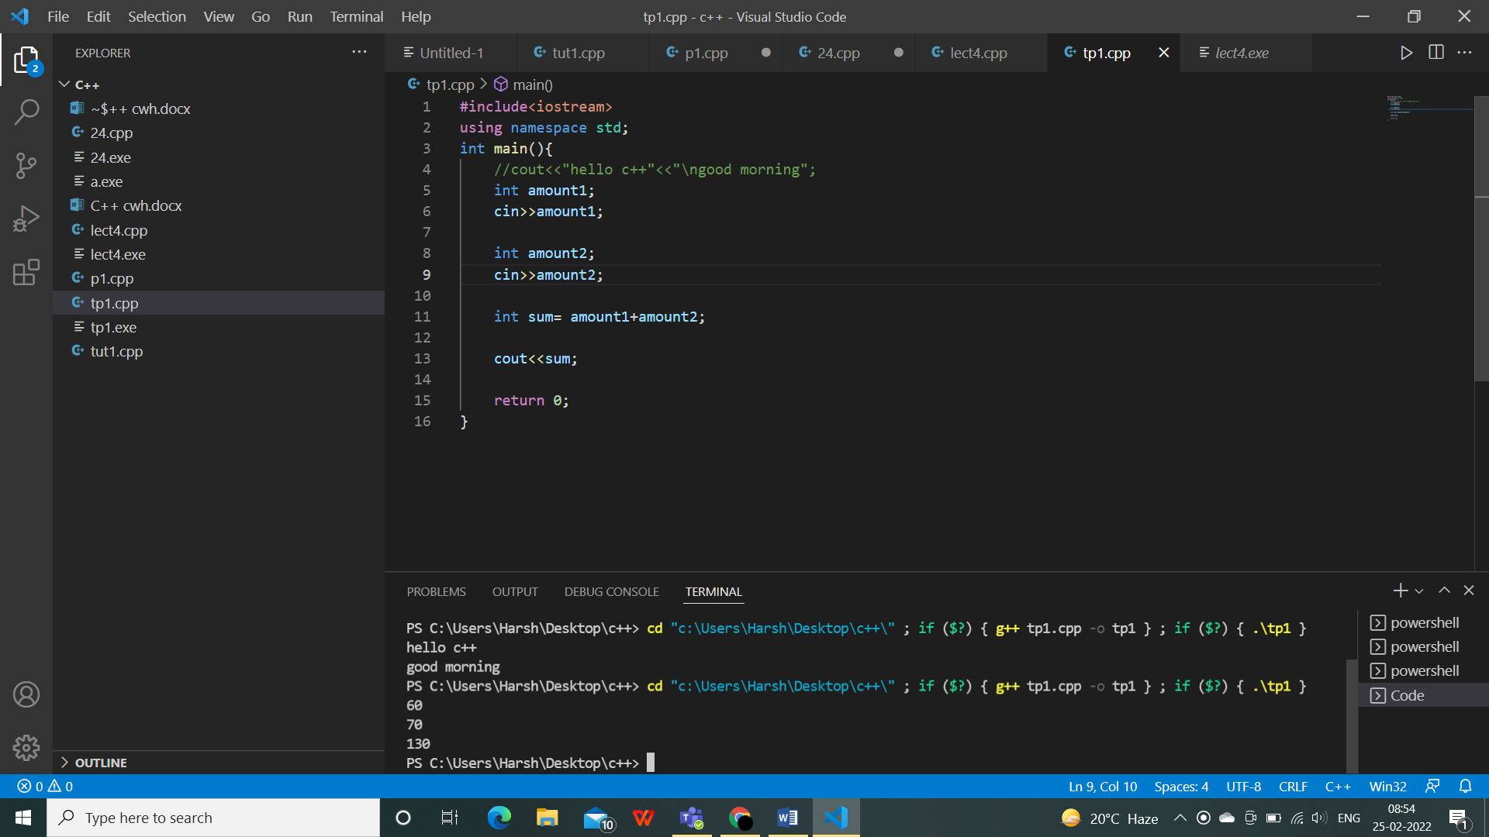

If(condition){code,result}

Else{result}

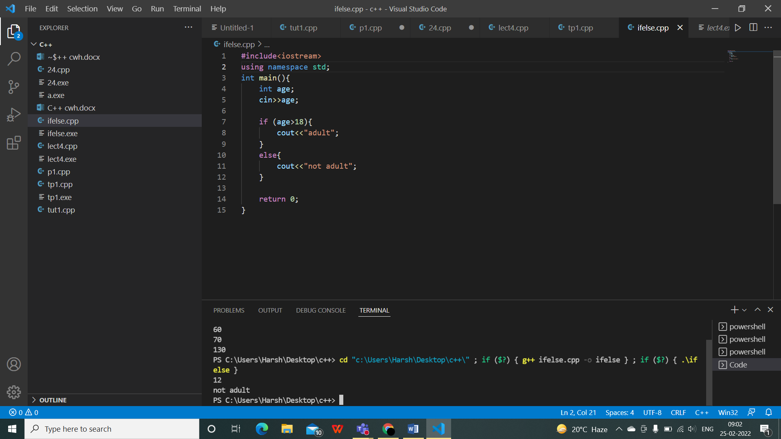

q) Greatest of 3 numbers

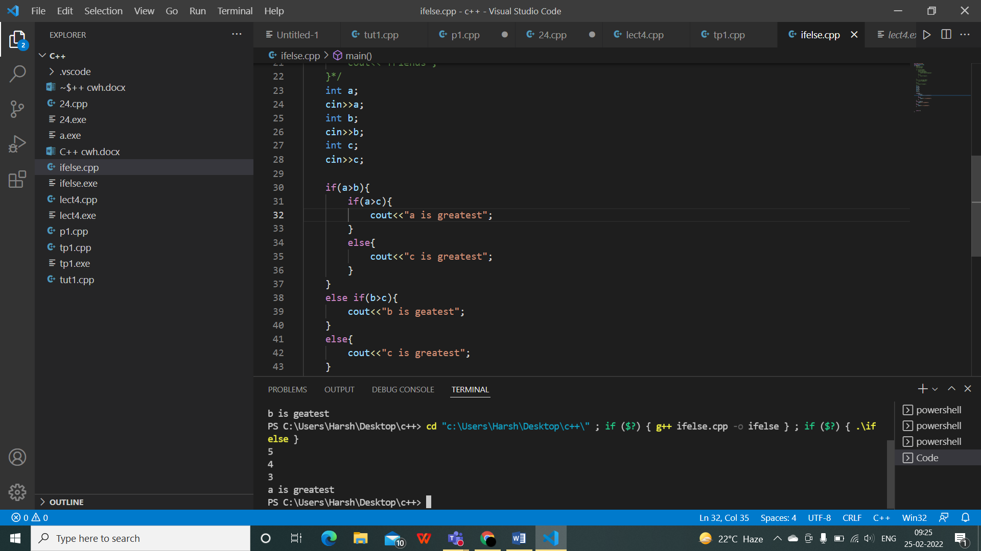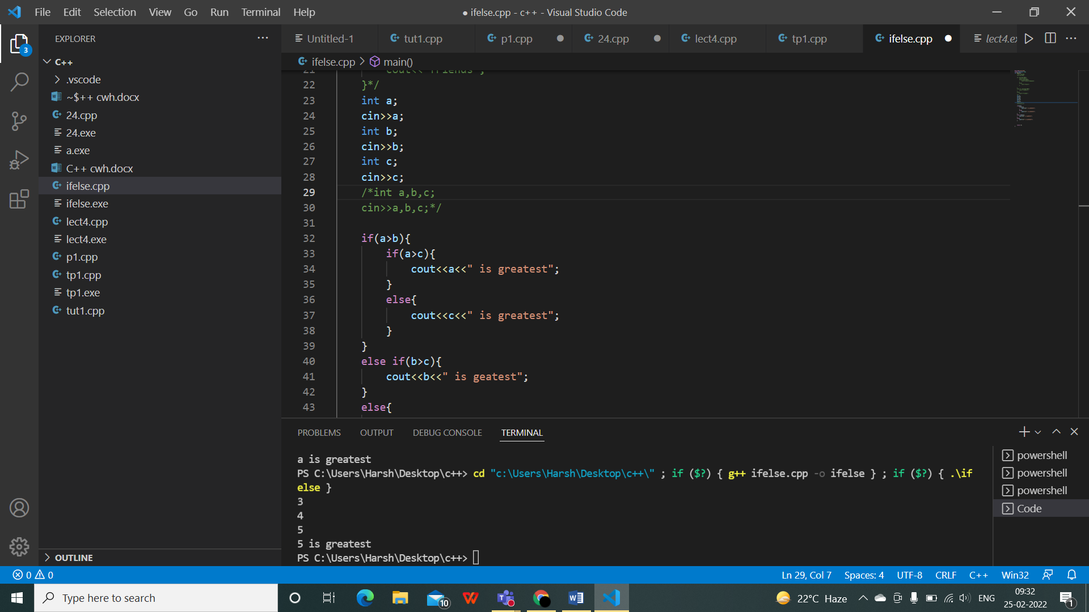

q) even or odd

